

Fingertip Application Method

For Estrogen Cream

- Wash your hands with soap and water and dry thoroughly.

- Squeeze tube to express out 1 gram of cream (about enough to cover the tip of your index finger, from the last joint to the finger tip. (see Figure 1)

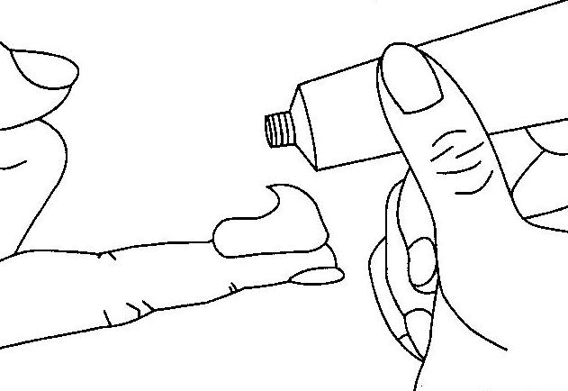

Figure 1

This instruction sheet is provided to help your practitioner explain his/her preferred method for applying estrogen cream. Your doctor or nurse will likely use this sheet to assist in their patient education activities. Please note that this information is not intended to replace your practitioner’s instructions: always follow your doctor’s specific directions regarding the use of any prescription medications

- Locate the vaginal opening (see Figure 2). Immediately above the vaginal opening is the urethra (a small opening where urine is eliminated from you body). The urethra may not be as easily identified as the vagina because the opening is much smaller, however, us the diagram to determine its approximate location.

- Carefully spread the cream onto the top wall of the vagina just underneath the urethral area (see Figure 2, yellow highlighted area). As the cream is spread, some may be gently inserted into the vagina: however, it is not necessary to push the cream high into the vagina. Rub this into the vaginal wall underneath the urethra as one would rub lotion into the skin.

- Do not use the applicator that may come with the prescription for the estrogen cream. Use only the small finger tip amount as noted above.

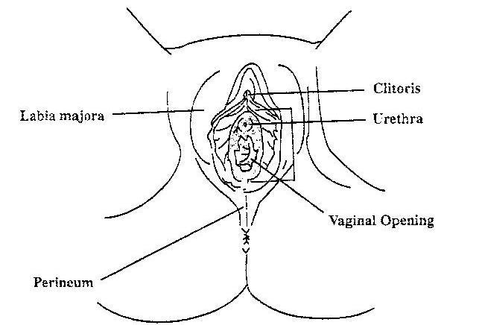

Figure 2

